Shenpaga Uma

Mail id: [umauma9925@gmail.com](mailto:umauma9925@gmail.com)

Phone Number: 437-662-7082

Ansible Task

**Aim:**

Using Ansible to automatically install an Apache and to configure a Hello World web page on a ubuntu machine hosted in vsphere.

**Steps and Screenshots:**

1. **Install Ansible on a machine of choice (your Ansible Local Machine)**

Using brew install ansible command to install ansible on a mac using brew package manager.

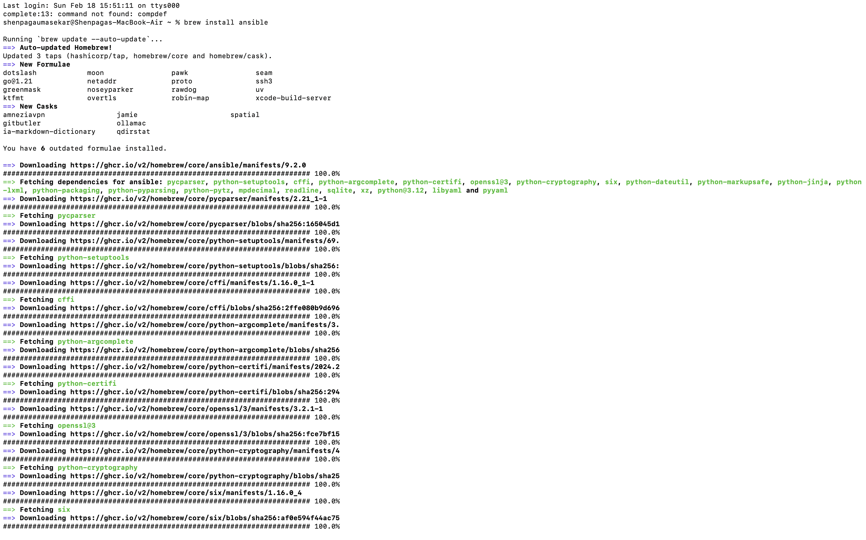

1. **Install a “fresh” remote Linux machine (e.g., Ubuntu 22.04) within the**

**Conestoga Lab.**

Deployed an Ubuntu based linux machine in the vpshere.

Virtual machine name: AnsibleHello

Ip Address: 10.173.145.8

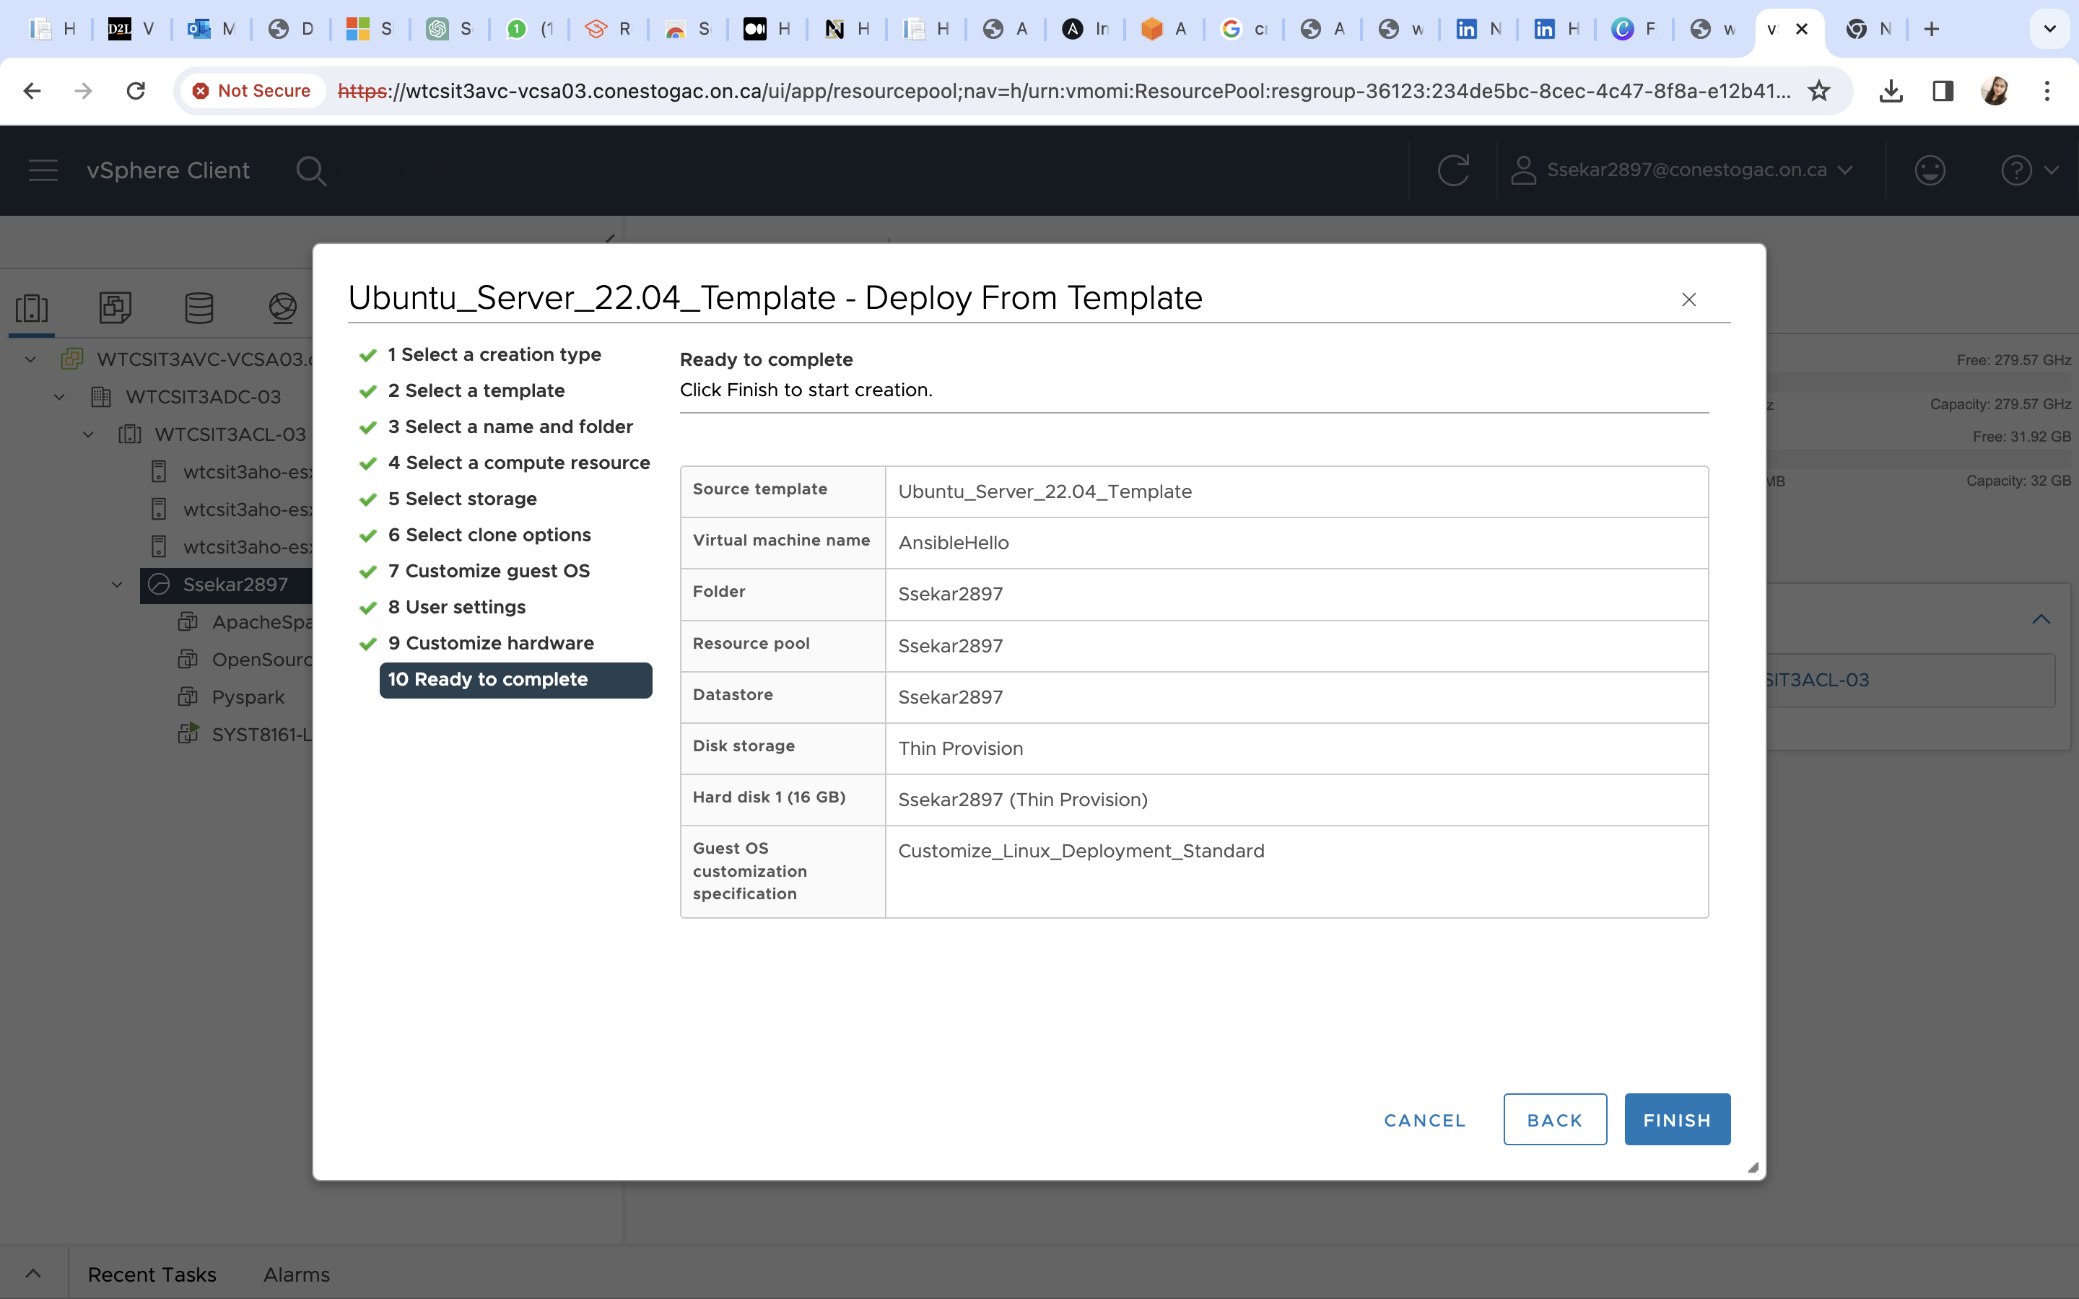

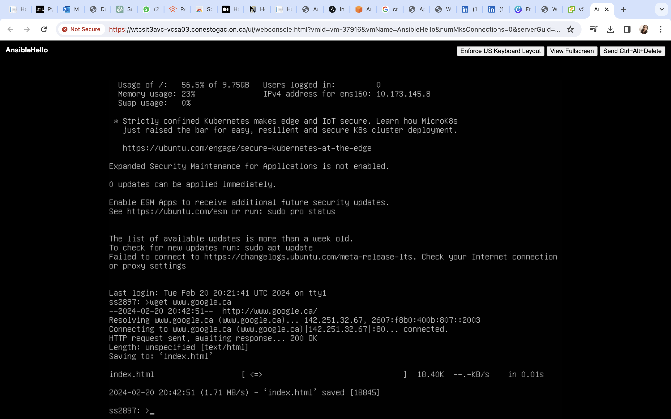

1. **Write an Ansible playbook that establishes the following on the remote**

**Linux machine:**

**• Install Apache**

**• Create a website (port 80) hosting a “Hello World” page**

Playbook named deploy_apache.yml created in the local machine where ansible installed

name: Deploy Apache website, this provides a description for the group of tasks.

hosts: here gave the hostname of the ubuntu machine where the tasks need to be executed.

become: to indicate tasks should be executed with privileges like sudo.

tasks: the tasks need to be executed, there are three tasks

1. name: name of the task “Install Apache “to install the apache server in the target machine. It uses apt module to install acpache2 if it is not present.

2. name: ‘Create Hello world HTML file’ this task is to create the hello world text which uses copy module and paste it in the destination location which is given in the dest: /var/www/html/index.html

3. name: ‘Restart Apache’. This component uses the service module to restart the apache to take effect of the changes made.

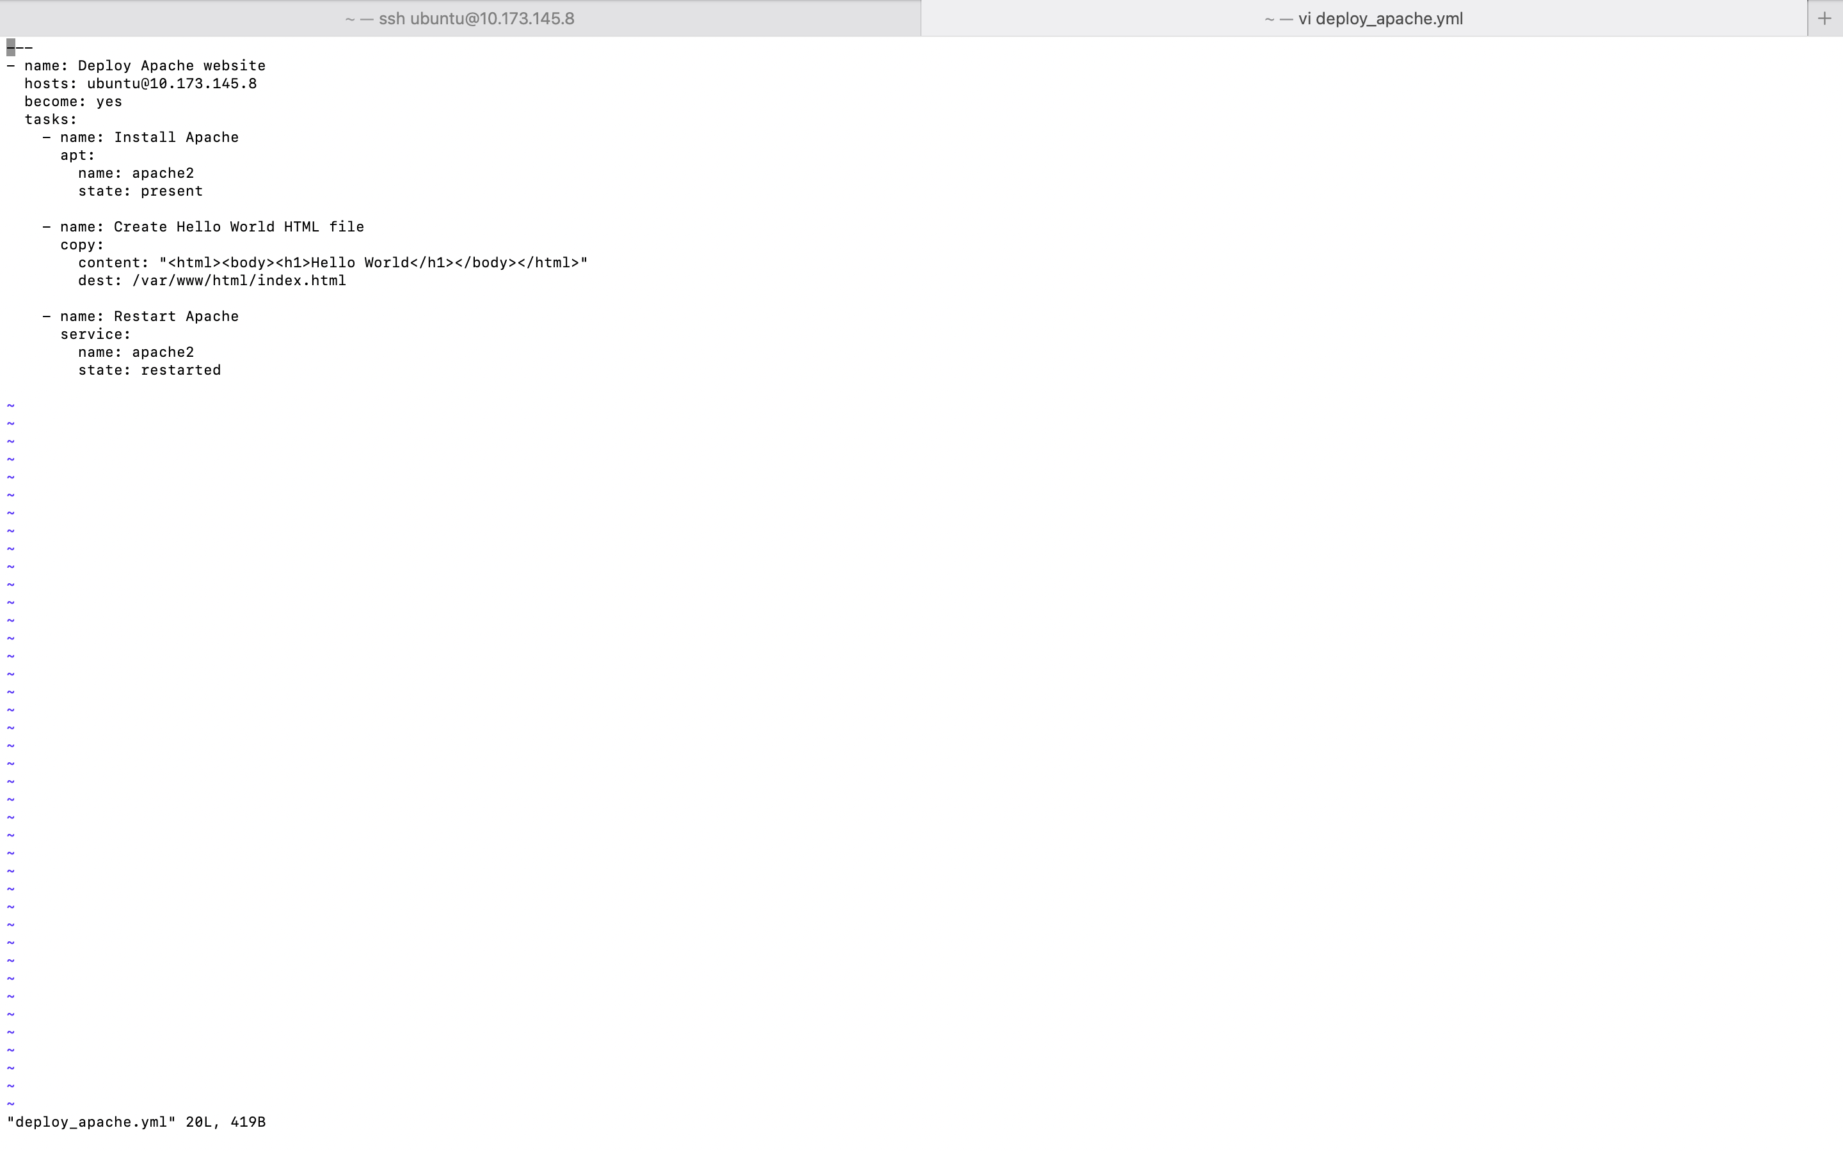

1. **Execute the Ansible playbook from the Ansible Local Machine**

Using the command ‘ansible-playbook –i [ubuntu@10.173.145.8](mailto:ubuntu@10.173.145.8) --ssk-become-pass deploy_apache.yml’ executed the ansible playbook. --ssk-become-pass to ask the password when executing.

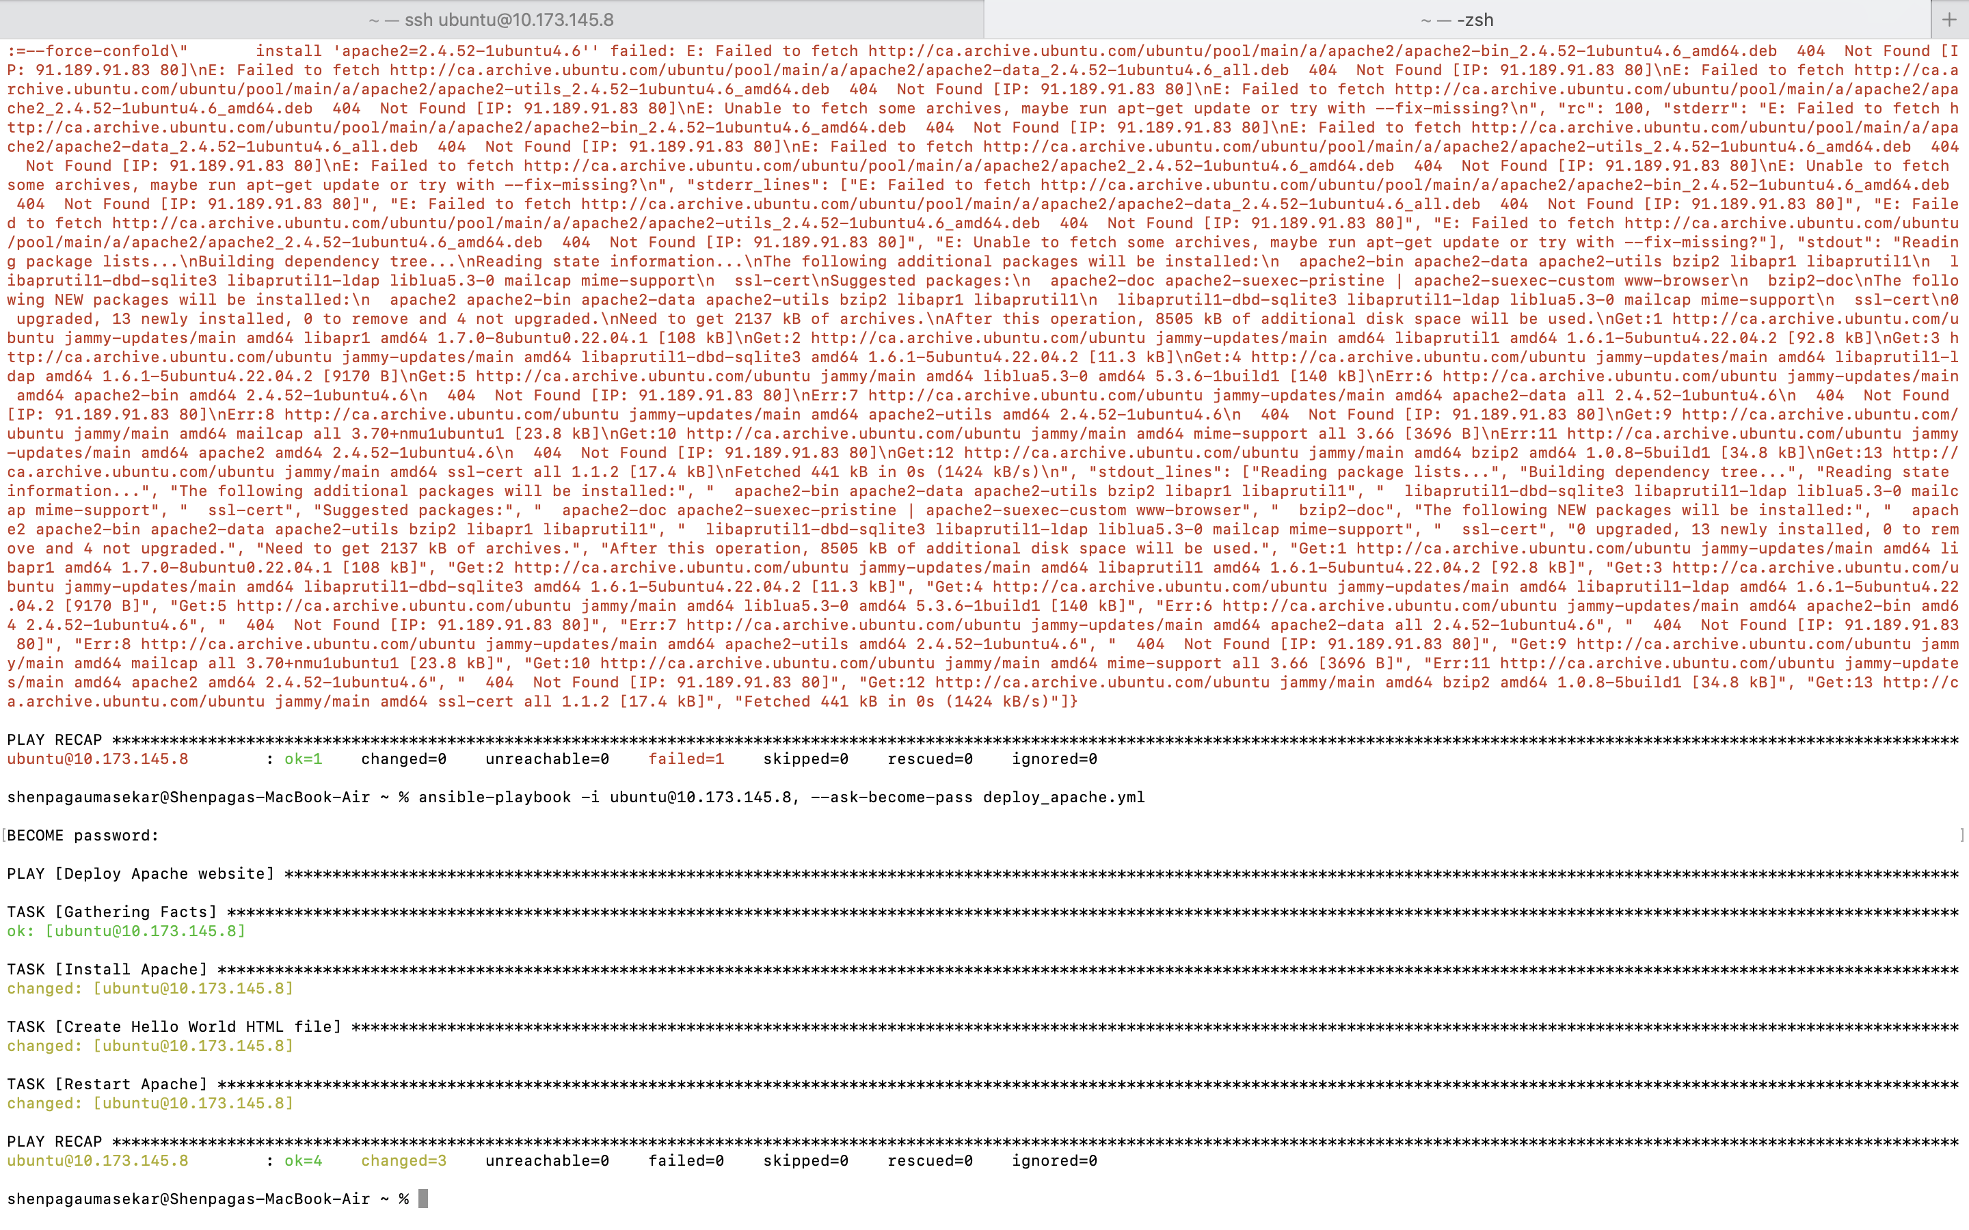

Faced issues while giving the above command so made changes in the configuration such as generating public key of the local machine and adding that in the authorized keys of the host machine. Did this step to login to the host machine without prompting for the password to login.

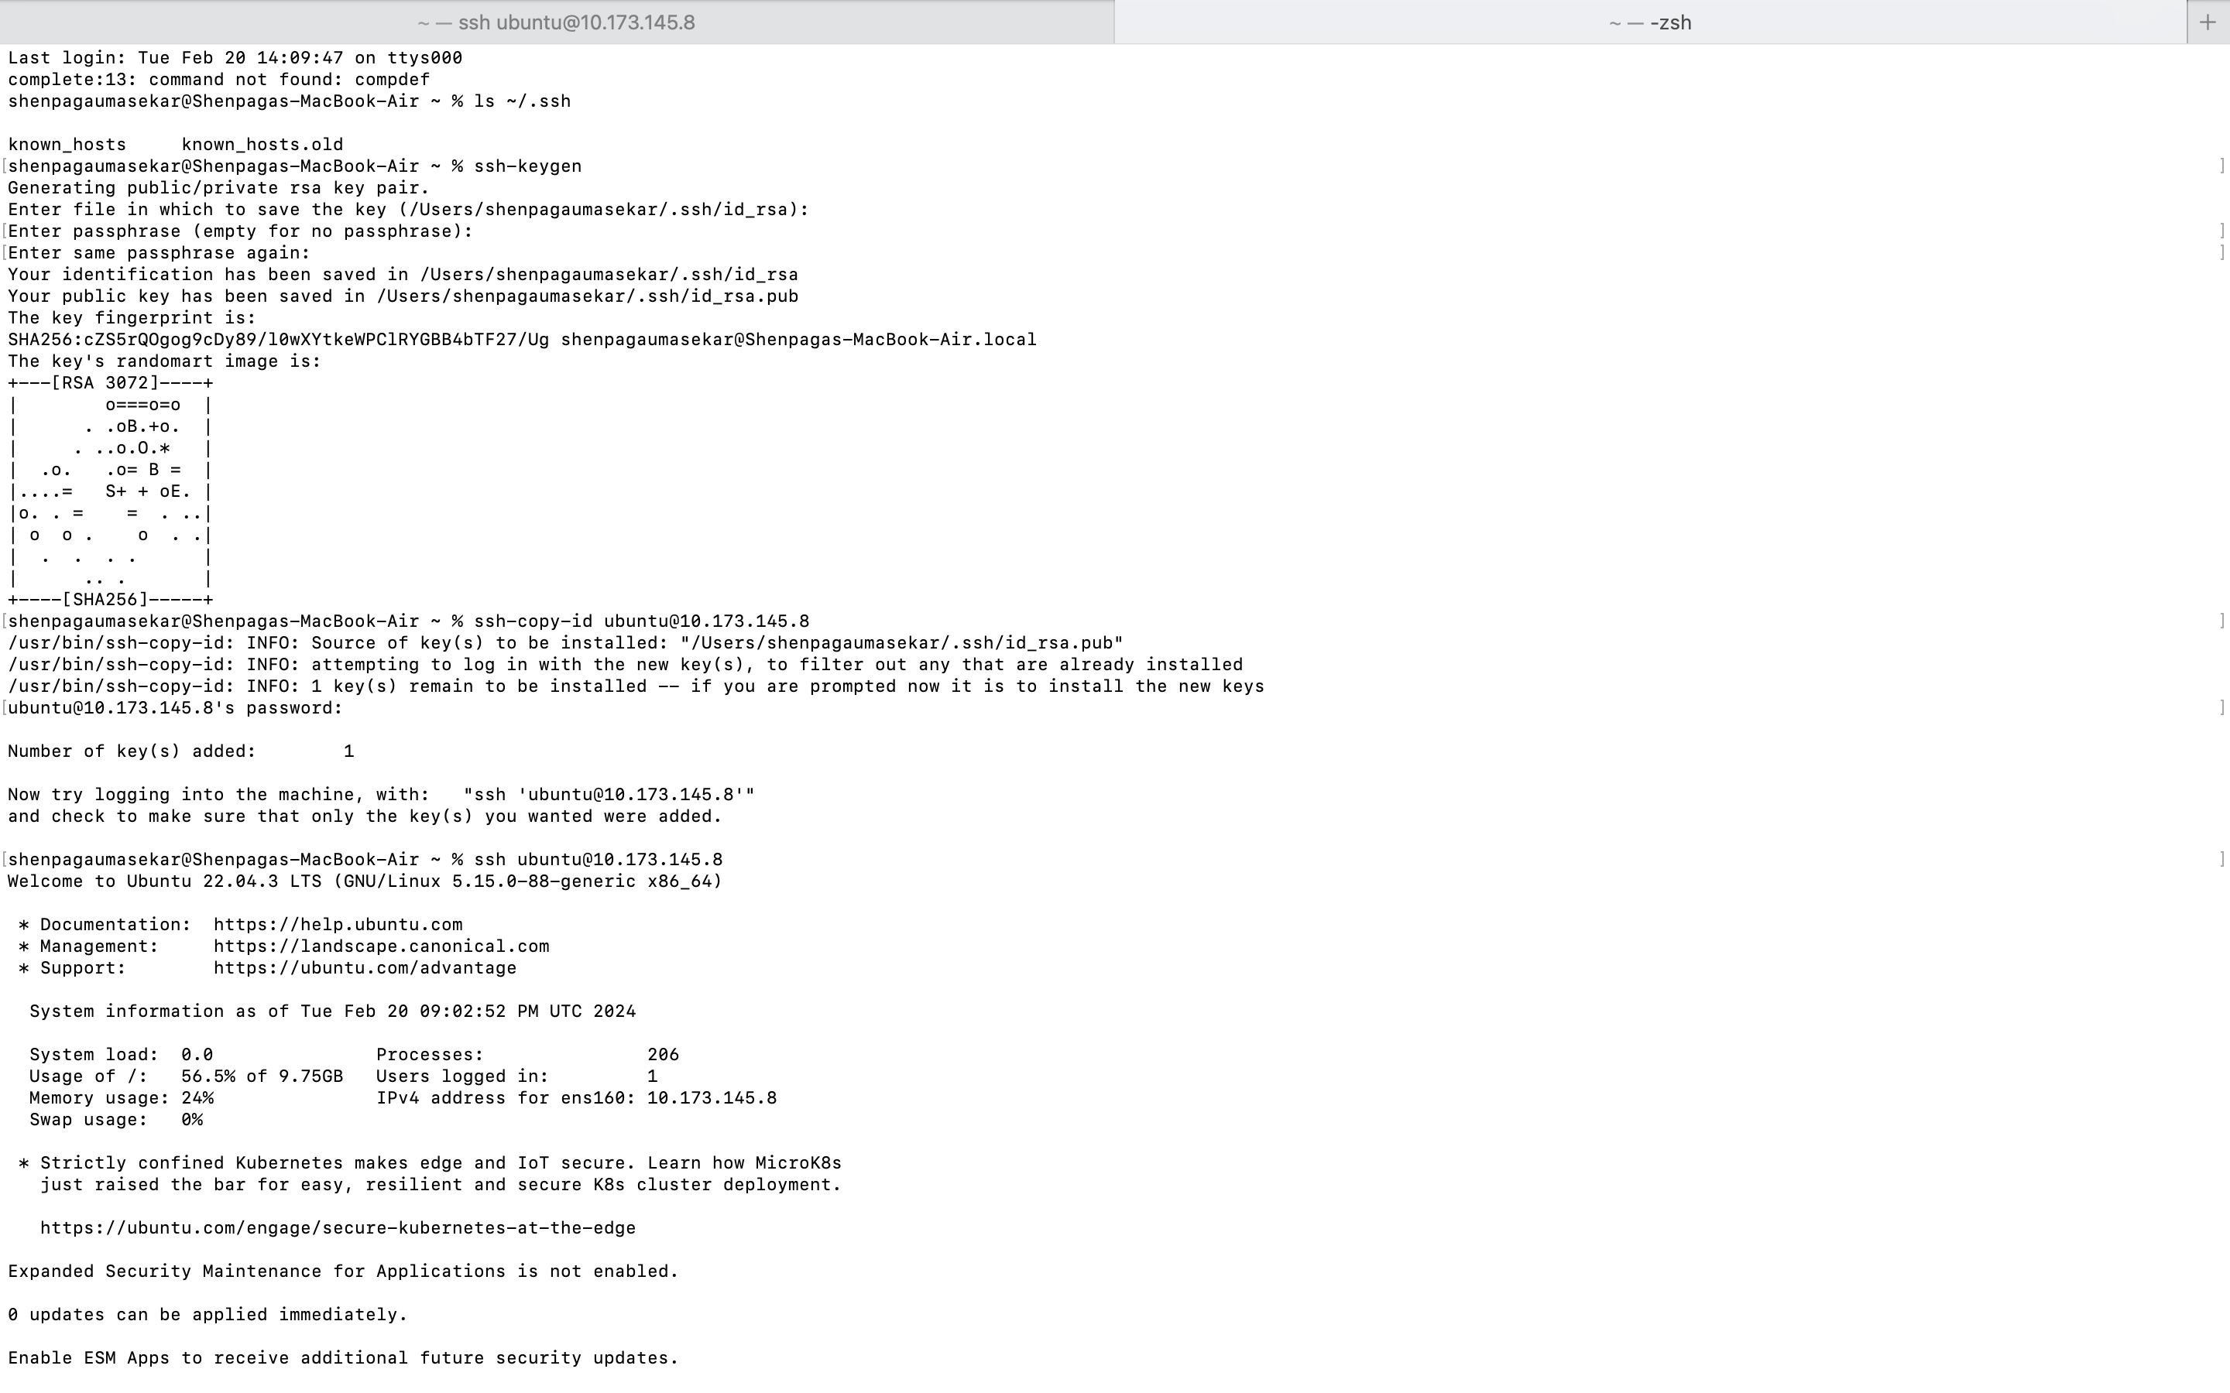

Allowed traffic on port 80 to access to the server using sudo ufw allow 80

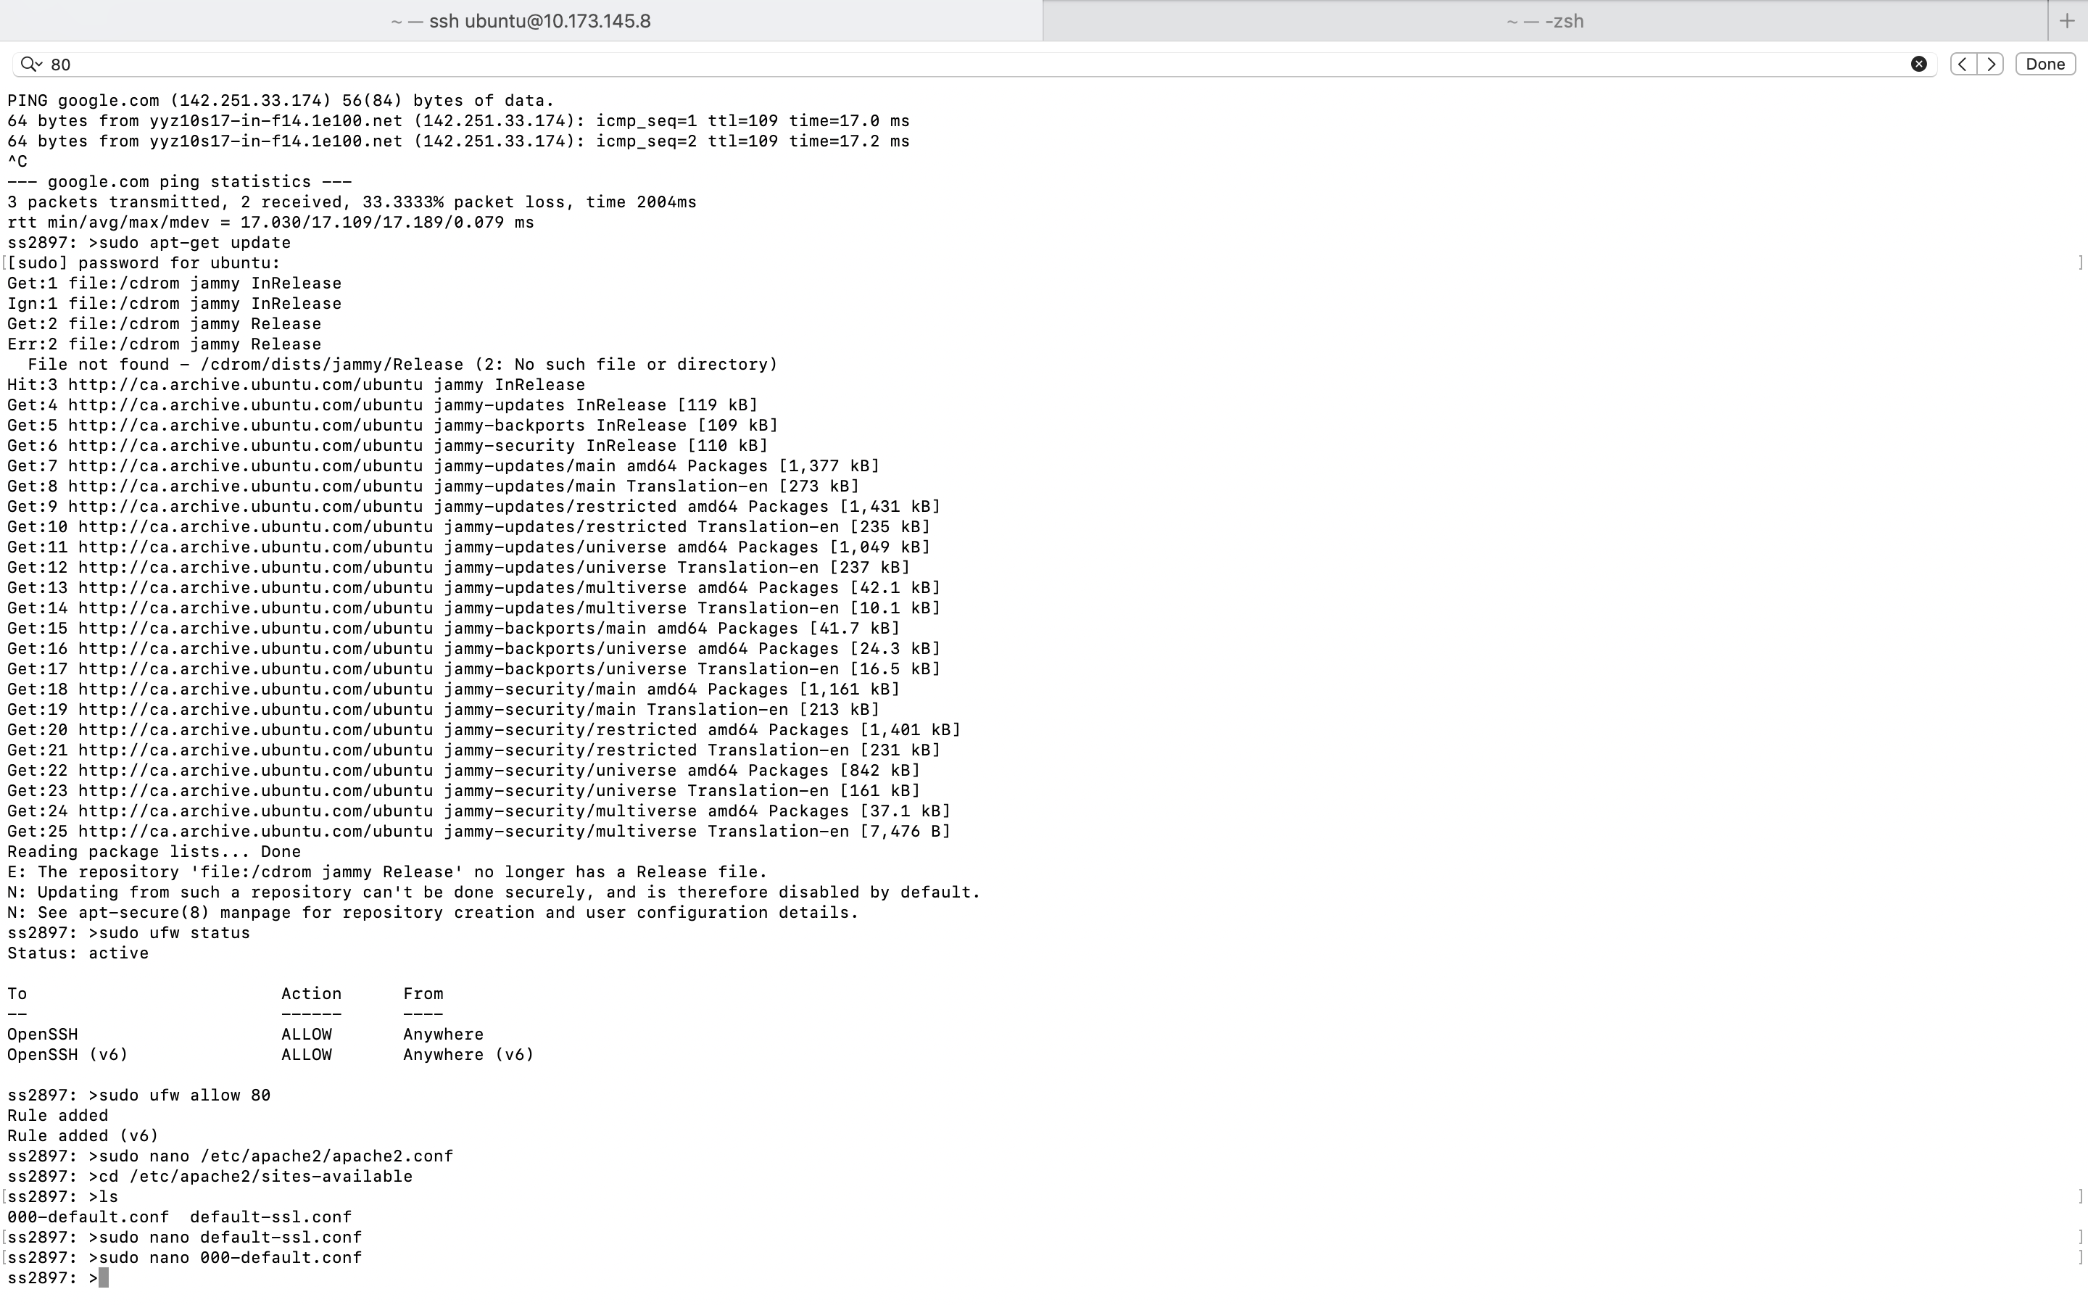

1. **Connect to the website to verify success**

After hitting the ip address of the hostmachine, got the Hello World webpage



**Outcomes**:

Learned Ansible, how to create playbook and execute them to automate the actions in the remote machines. Solved issues which raised during the tasks.

**References**

*Installing Ansible — Ansible Documentation*. (n.d.). <https://docs.ansible.com/ansible/latest/installation_guide/intro_installation.html>

*Learning Ansible basics*. (n.d.). <https://www.redhat.com/en/topics/automation/learning-ansible-tutorial>

*Basic concepts — ansible documentation*. (n.d.). <https://docs.ansible.com/ansible/latest/network/getting_started/basic_concepts.html>